**Smart River-Monitoring System**

This embedded project is based on 4 subsystems.  
  
Figure 1 - System schema

The system is composed of 4 subsystems:

* **water-level-monitoring** subsystem (ESP32):
  + embedded system to monitor the water level of a river
  + it interacts with the *river-monitoring-service* subsystem (preferably via MQTT but HTTP can be used as a second option)
* **water-channel-controller** subsystem (Arduino):
  + embedded system controlling the gate/valve of a water channel
  + it interacts via serial line with the *river-monitoring-service* subsystem
* **river-monitoring-service** subsystem (backend - running on a PC server):
  + service functioning as the main unit governing the management of the Smart River-Monitoring System
  + it interacts through the serial line with the *water-channel-controller* subsystem
  + it interacts via MQTT with the *water-level-monitoring* subsystem
  + it interacts via HTTP with the *river-monitoring-dashboard* subsystem
* **river-monitoring-dashboard** subsystem (frontend/web app - running on the PC):
  + frontend to visualize and track the state of the *river-monitoring-service* subsystem
  + it interacts with the *river-monitoring-service* subsystem via HTTP

1. **Water Level Monitoring**

It runs on ESP32-S3 [devkitC-1 n16r8v](https://github.com/EnryMarch10/SmartRiverMonitoringSystem/blob/develop/water-level-monitoring/boards/esp32-s3-devkitc-1-n16r8v.json).

Manages the water level sampling and is coordinated by the River Monitoring Service.

At first, it connects to WIFI through given credentials. Credentials must be correct for the system to work, so they must be set “location dependently”. If WIFI disconnects the SoC tries to reconnect to it. If the connection can’t be established for any reason the ESP32 is unable to communicate with the River Monitoring Service, so the System does not work properly.

If the WIFI connection is established correctly than the SoC can connect with the MQTT broker, particularly [broker.emqx.io](https://www.emqx.com/en/mqtt/public-mqtt5-broker). The connection is secured by attacks because TLS is used to identify the correct server thanks to a certificate (source <https://github.com/emqx/MQTT-Client-Examples>).  
In this case two topics are considered:

* *SmartRiverMonitoringSystem/WaterLevelMonitoring/Period*, where the new frequency (period in implementation) is sent from the River Monitoring Service to this subsystem and the water level sampling changes consequently
* *SmartRiverMonitoringSystem/WaterLevelMonitoring/WaterLevel*, where this subsystem publishes the water levels sampled at the specified frequency
* 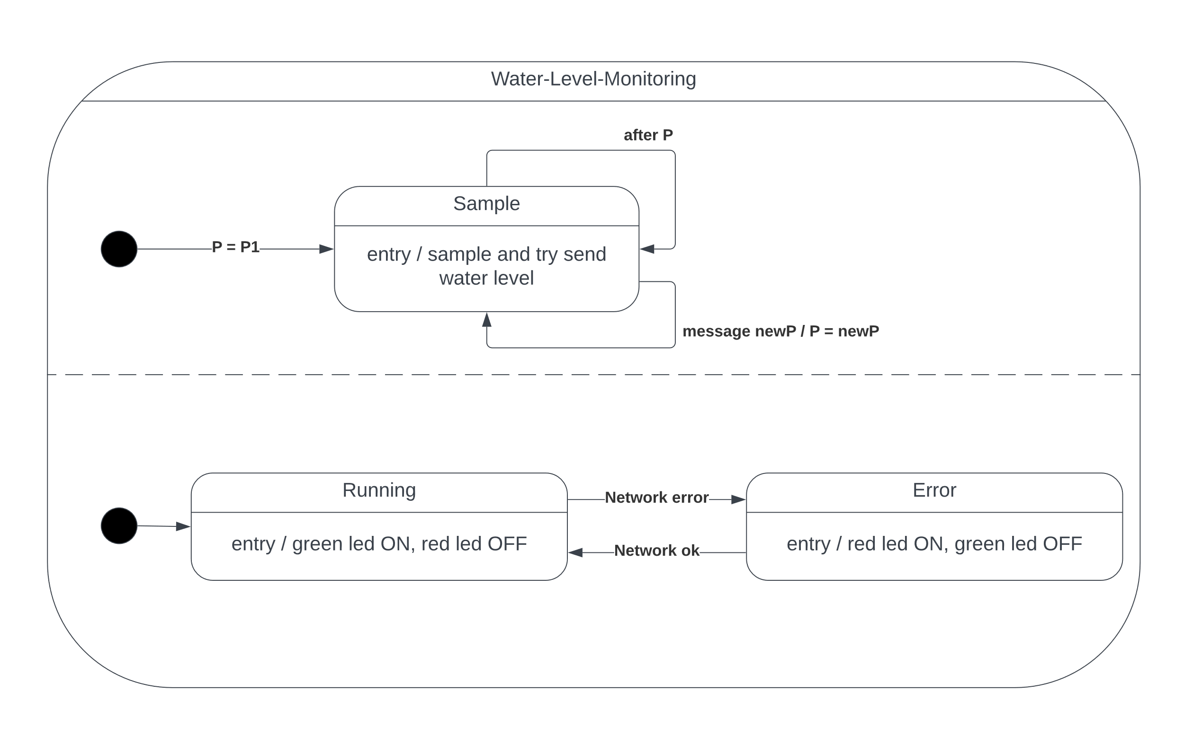When the system works correctly, the network is OK, a green led is on, while when there are some errors, a red led is turned on instead.

Figure 2 - Water Level Monitoring FSMs

1. **Water Channel Controller**

It runs on ARDUINO UNO.

Manages the valve opening level in AUTOMATIC or MANUAL modalities.

It does not need the network because it communicates with the River Monitoring Service via serial line.

It manages the modality of the system that can be:

* LOCAL - it is toggled by a button
  + AUTOMATIC – it is coordinated by the River Monitoring Service in whatever modality it wants
    - WHATEVER – the River Monitoring Service decides the valve opening level from remote (via serial communication)
  + MANUAL – it reads the value of a potentiometer and sets the valve opening level according to the read value
* REMOTE - it is toggled by the communication with the River Monitoring Service and is triggered by the River Monitoring Dashboard

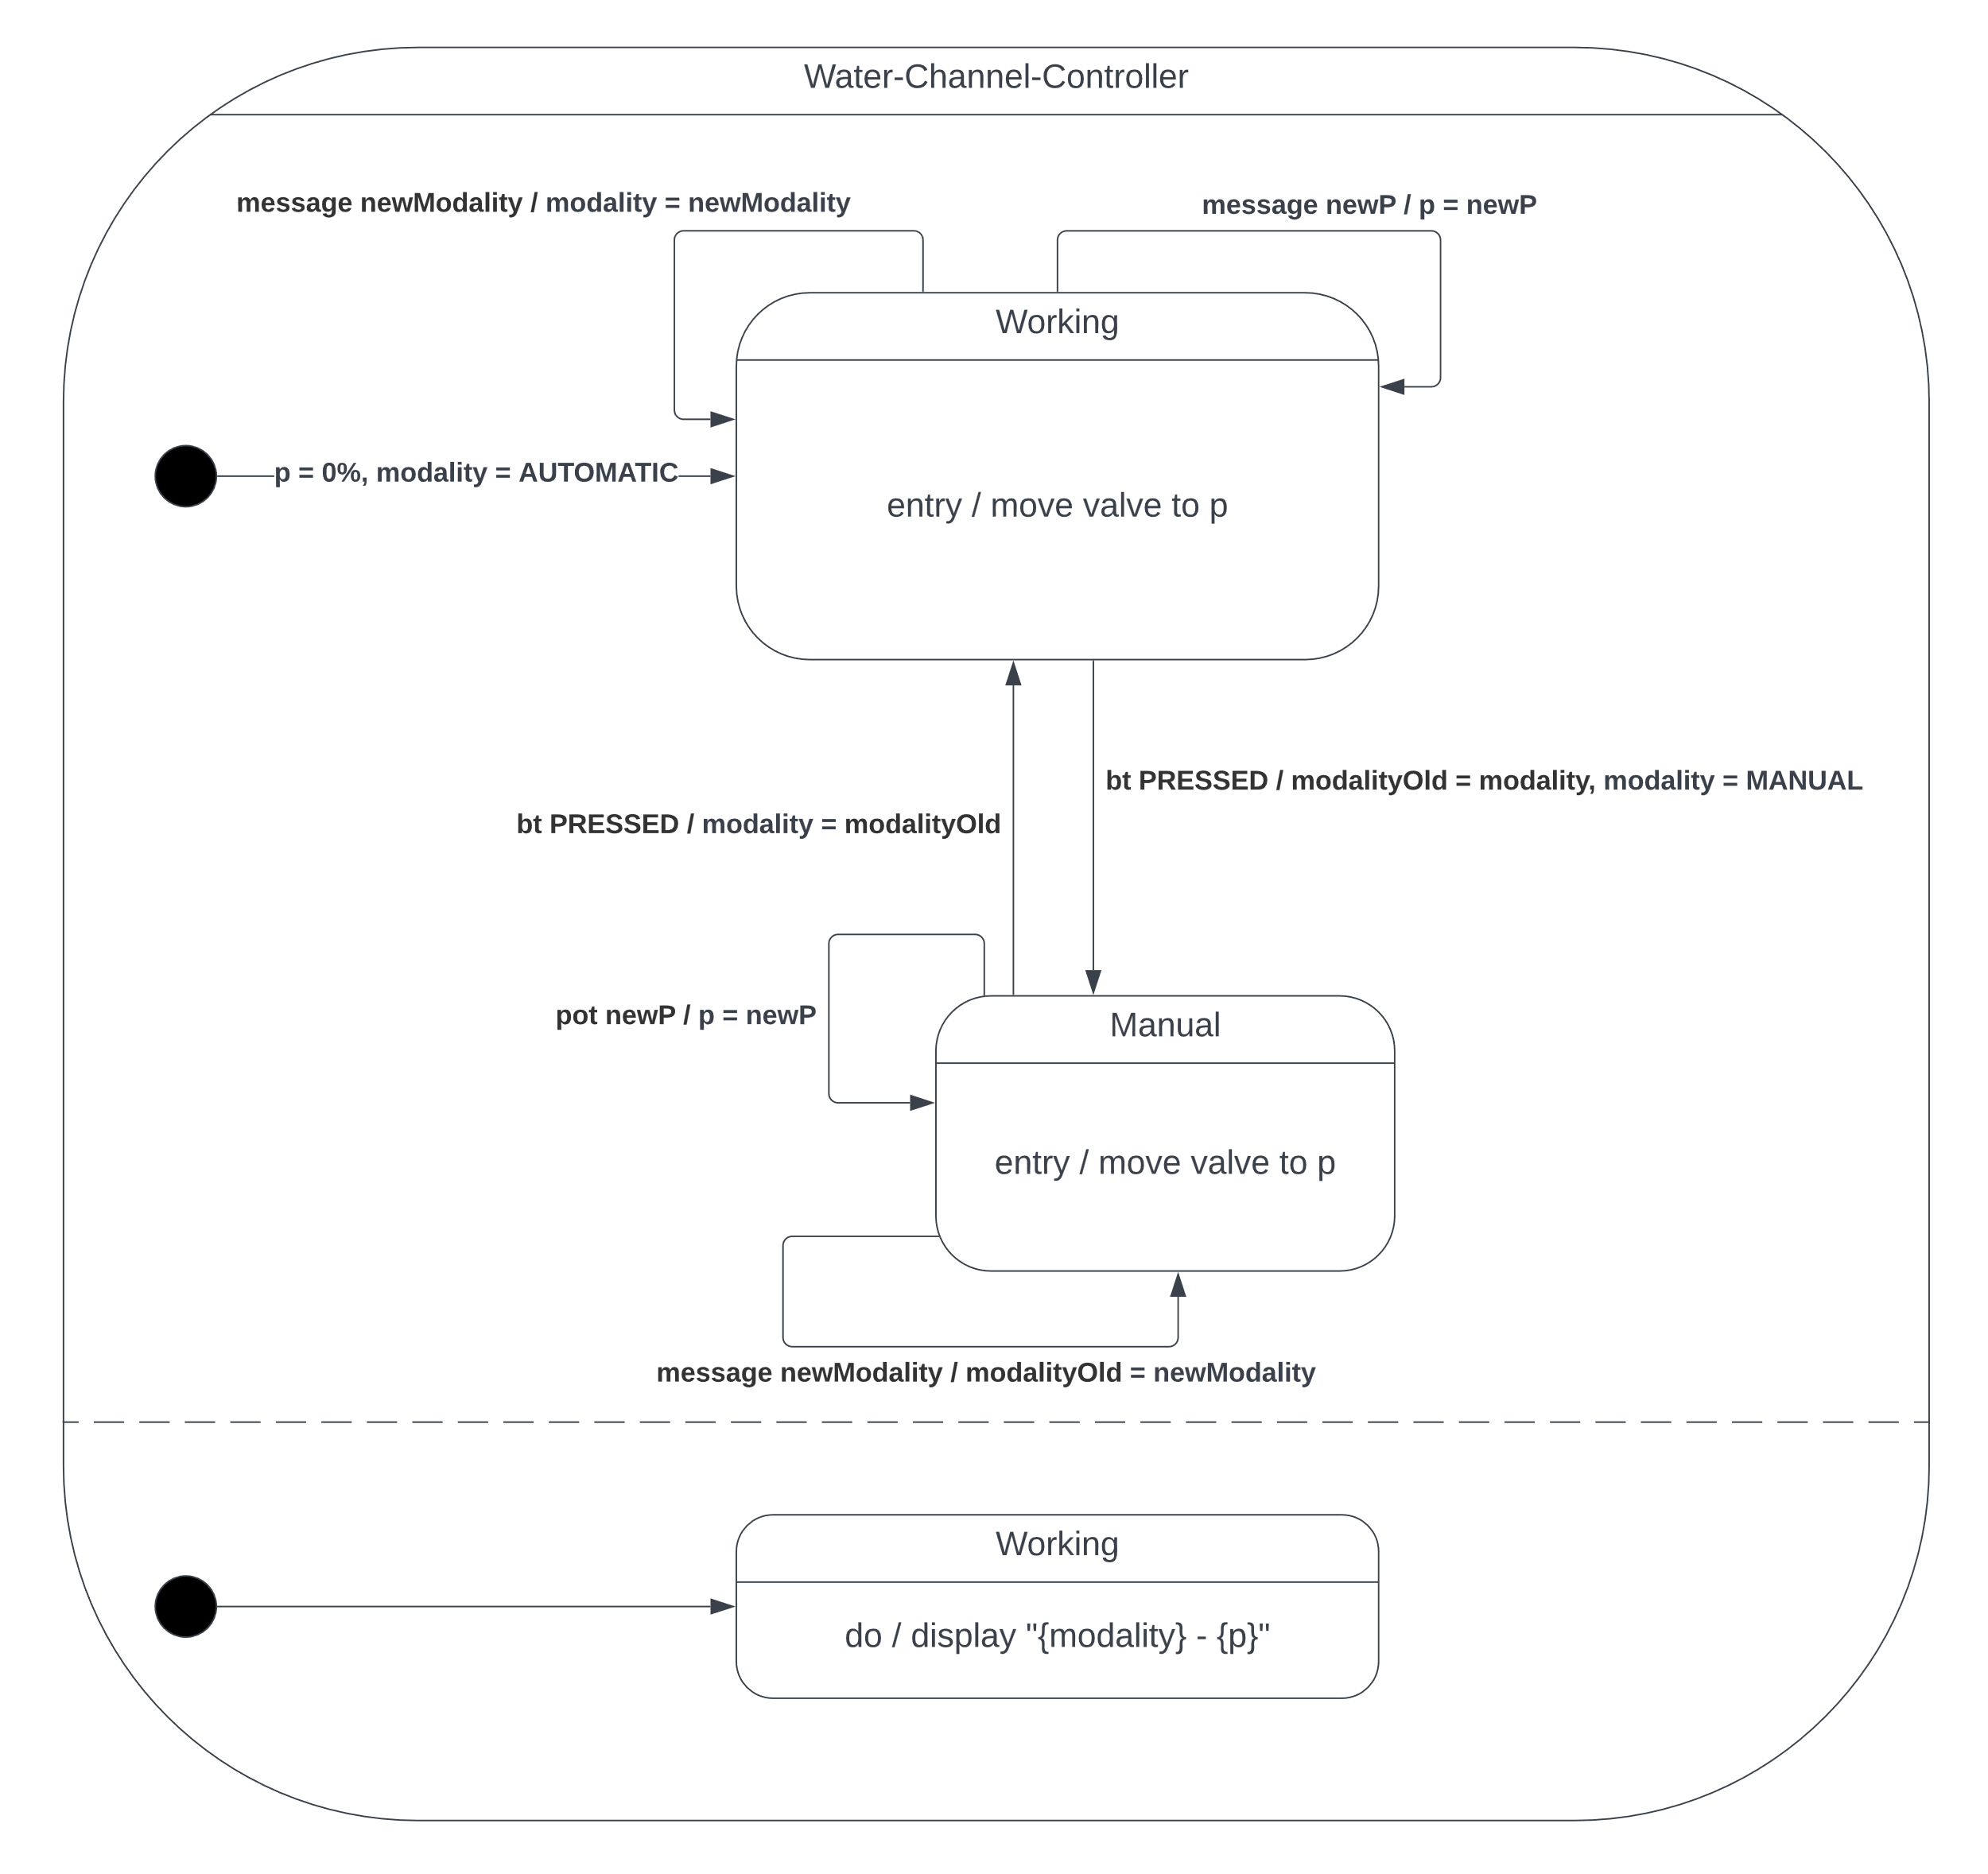Modality and valve opening level are showed in a display.

Figure 3 - Water Channel Controller

1. **River Monitoring Service**

It runs on the PC. In my case I chose a Python application.

|  |  |  |
| --- | --- | --- |
| STATE | WATER LEVEL SAMPLING PERIOD (s) | VALVE LEVEL (%) |
| ALARM-TOO-LOW | 10 | 0 |
| NORMAL | 10 | 25 |
| PRE-ALARM-TOO-HIGH | 2 | 25 |
| ALARM-TOO-HIGH | 2 | 50 |
| ALARM-TOO-HIGH-CRITIC | 2 | 100 |

Manages the system policy as requested. This service can be considered the core of the system. The different states trigger a change in the behaviors of the two previously described subsystems:

The modality of the Water Channel Controller could also be managed by the River Monitoring Dashboard that can set it as MANUAL. In this case if the Water Channel Controller accepts the valve opening level can be set directly by an operator from remote, independently from the described policy of this subsystem. It would be nice to manage a timer to avoid MANUL modality always forget on (this could cause an unexpected behavior).

This service communicates via MQTT with the Water Level Monitoring signing to the described topics in the specular way. Even here the same MQTT broker and TLS system is used (source <https://github.com/emqx/MQTT-Client-Examples>). In particular:

* *SmartRiverMonitoringSystem/WaterLevelMonitoring/Period*, in this case the subsystem sends the period
* *SmartRiverMonitoringSystem/WaterLevelMonitoring/WaterLevel*, in this case the subsystem listens for the water level

Furthermore, if in AUTOMATIC or MANUAL remote mode (from Dashboard) this system sends the valve opening level in percentage to the Water Channel Controller via serial communication.

1. **River Monitoring Dashboard**

It runs on the PC. In my case I chose a Flask (Python) web application.

…

